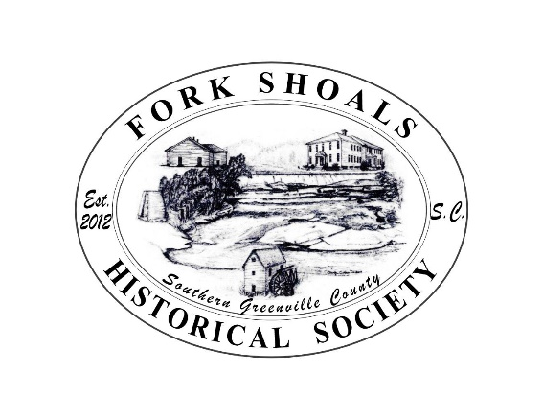
Fork Shoals Historical Society
Post Office Box 442
Pelzer, South Carolina 29669

December 16, 2024

Thanks to all at the Park Service! We are excited to turn in our final Summary Report for the $250,000 you oversaw for our McCullough House Restoration Project.

Project Goals and Completions
The goal of this project was to restore the McCullough’s Historic Home and Inn (1812) that will interpret the early development and agricultural history of Southern Greenville County during the antebellum period. This first funding stabilized the exterior brick and mortar and begin the restoration of the 9 over 9 and the 9 over 6 windows. The work on the brick and some of the window work has been completed. There was a small overrun on the brick which caused the windows to be partially funded. That will be supplemented from other funding sources. With Legislative Funding 2025, the house’s porches, windows, doors, roof, and interior will be replaced or restored under the State Museum Commission. Further funding will be requested for 2026 to complete the gardens, kitchen building, and other structures.
Public Benefit
McCullough’s Cedarhurst signifies the life and times of southern Greenville County’s rural plantations and inns of the antebellum period through 1855. With the proximity of the house to the busy US Highway 25, travelers have watched Cedarhurst decompose, and they are excited about her rejuvenation. Passersby, young and old, knew there was something special going to waste. Now, excitement builds and the anticipation of Cedarhurst opening as a museum is intensifying. The public will be able to enjoy the preserved building and learn the history of backcountry life covering Caucasian and African contributions to the growth of farming, travel, and industry during the 1800s. Cedarhurst will draw students and tourists to Southern Greenville and other local historical sites such as Fork Shoals mill village, historic Cedar Falls Mill Park, Chapman Grove Rosenwald School, Holly Spring Colored School, Lickville and Fairview Churches. Local docents will be trained to share more than the displays will portray. A committee of descendants of the McCulloughs and the enslaved, as well as society members will plan the teaching displays and programs. Our goal is to build ties to the local African American community to ensure understanding, cooperation, good will, and ongoing success. Accommodations for public and home school groups as well as adult organizations will be incorporated. And the dwelling and gardens will also be available to the community for gatherings. Plans are to rebuild the gardens, kitchen building, and at least one slave cabin and then increase the acreage available for a park.

Gratefully,
Anne C. Peden, Phd.
Vice Chairperson
Fork Shoals Historical Society

