Statement of Non-Discrimination
By Organizations Funded in the
South Carolina General Appropriations Act

To meet requirements of a provision of the South Carolina General Appropriations Act regarding your funding, please fill in the blanks below, sign and return to PRT with your other credentials. If desired, you may retype the statement on your own letterhead.

Statement of Non-Discrimination

October 1, 2022
Date

Assurance is hereby given by the

Friends of the Green Crescent Trail
(Name of Organization)

that no person shall, upon the grounds of race, creed, color or national origin be excluded from

participation in, be denied the benefit of or be otherwise subjected to discrimination under any

program or activity for which this organization is responsible.

Signature :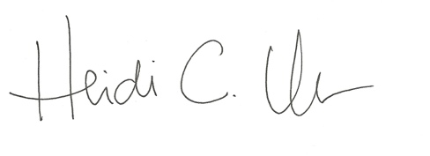

Title: Chairperson

