Statement of Non-Discrimination
By Organizations Funded in the
South Carolina General Appropriations Act

Statement of Non-Discrimination

October 7, 2022 .
Date

Assurance is hereby given by the

International African American Museum
_____________________________________________________________________
(Name of Organization)

that no person shall, upon the grounds of race, creed, color or national origin be excluded from

participation in, be denied the benefit of or be otherwise subjected to discrimination under any

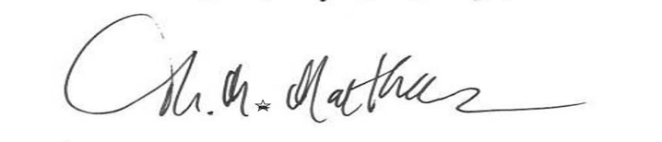
program or activity for which this organization is responsible.

Signature _________________________________

Title ___President and CEO _______________________

