SOUTH CAROLINA DEPARTMENT OF PARKS, RECREATION
&
TOURISM

PROCUREMENT CERTIFICATION FORM

GRANTEE NAME: International African American Museum

PROJECT NAME: Statewide African American History Tourism and Marketing

I hereby certify that all labor, materials and contracts
acquired or performed in the accomplishment of the above named project will be accomplished in accordance with the named entity’s established procurement guidelines. Any questions, concerns or grievances should be directed to this agency.

Tonya M. Matthews, PhD
PRINTED NAME
President and Chief Executive Officer
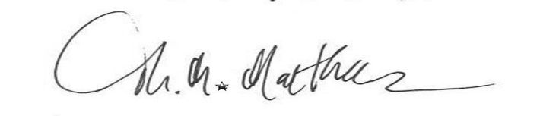
TITLE
___________________________________
SIGNATURE
October 7, 2022
DATE

